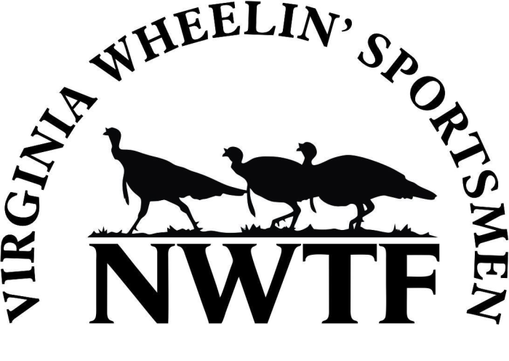
2019 VAWS Dove Hunt Application

We have some great dove hunts planned for this fall. All of our events are free and open to anyone with a disability. You are welcome to bring one friend or family member with you. Meals will be provided as posted below. Please complete page 2, putting a check mark beside the events you would like to attend, and the total number attending.

Dove Hunt Registration deadline – August 20th

Warsaw Ultimate Dove Hunt – Thur. September 12 – Warsaw, VA
We’ll return to Warsaw for our 8th annual Warsaw Ultimate Dove Hunt on Thursday, September 12th near Warsaw, VA. This hunt will be held on the 2,000 acre Sabine Hall Plantation along the Rappahannock River, planted with corn, sunflowers and millet. Each participant is allowed to bring one person with them and that person may also hunt. Dinner immediately following the hunt. Please wear camo, and bring your shotgun and dove ammo of choice.

Covered Spring Farm Dove Hunt – Sat. September 14 – Columbia, VA
Please join us at our 3rd annual Covered Spring Farm Dove Hunt on Saturday, September 14th. We will meet at the farm at 11:30, have lunch, select stands, and then head to the fields. Each participant is allowed to bring one person with them and that person may also hunt. Water will be provided throughout the afternoon. Please wear camo, and bring your shotgun and dove ammo of choice.

Occoneechee State Park Dove Hunt – Sat. September 14 – Clarksville, VA
The Staunton-Meherrin Chapter will team up with Virginia State Parks to host this first hunt at Occoneechee State Park on Bugg’s Island Lake. The Chapter funded a habitat project on the park and it should offer some great shooting. Each participant is allowed to bring one person with them and that person may also hunt. Dinner immediately following the hunt. Please wear camo, and bring your shotgun and dove ammo of choice.

Outdoor Dreams Dove Hunt – Fri. September 27 - Gladstone, VA
Please join us at our 2nd annual Outdoor Dreams Dove Hunt on Friday, September 27th. We will meet in Lovingston (Nelson, Co.) and then drive to the hunt site. Each participant is allowed to bring one person with them and that person may also hunt. Please bring your own drinks and snacks. Please wear camo, and bring your shotgun and dove ammo of choice.

2019 Virginia Wheelin’ Sportsmen
Dove Registration Form

Please check the event(s) you wish to attend, and complete the registration form below. You may bring one person with you.
***Dove Registration Deadline is August 20th! ***
______ Warsaw Ultimate Dove Hunt – Warsaw – Thursday, Sept. 12 Total attending ______
______ Covered Spring Farm Dove Hunt – Goochland - Saturday, Sept. 14 Total attending ______
______ Occoneechee State Park Dove Hunt – Clarksville - Saturday, Sept. 14 Total attending ______
______ Outdoor Dreams Dove Hunt – Gladstone – Friday – Sept. 27 Total attending ______

Name: _______________________________________________________________________________
Address: _____________________________________________________________________________
City: _____________________________________________________ State________ Zip ___________
Home Phone: (_____)____________________ Work/Cell Phone: (_____)________________________

Email Address:________________________________________________ Age:________ Sex:_________

Describe your Mobility Impairment: ________________________________________________________

_____________________________________________________________________________________

Ambulatory _____ Manual _____ Power Chair _____

Mail To: VAWS - Robin Clark
3081 Monacan Trail Rd – North Garden, VA 22959
or E-mail to: huntvaws@gmail.com

Questions? – Contact Robin Clark - 434-249-6154 or huntvaws@gmail.com

